New Hampshire Right to Life


Post Office Box 421 Merrimack NH 03054
603.626.7950 life@nhrtl.org www.nhrtl.org

July 7, 2005

Dear Pastor:

We are pleased to invite you and your congregation to the Third Annual pro-life picnic! Join us on Sunday afternoon, July 31, from 2pm to 7pm at Pawtuckaway State Park in Nottingham, NH for a great time of fellowship and fun with NH pro-lifers.

This picnic will feature lots of family fun with games like batmitton, potato sack races, frisbee, croquet, water balloon tosses, face painting, raffles, and music. The park slides, swings, and life-guarded beach are also available for use.

Bring your own meat and rolls and bring a salad or dessert to share. A donation to NHRTL for $5 per person to cover drinks, ice, snacks/chips and watermelon would be appreciated. A grill, all paper products, utensils, and condiments will be provided as well.

The State Park has an entrance fee of $3 for each adult, $1 per child aged 6 to 11. Children under 5 and NH residents age 65 and over are free. We have reserved the huge pavilion again. You can see past picnic photos at www.nhrtl.org/picnic/2004 or www.nhrtl.org/picnic/2003

Pawtuckaway State Park is about 15 miles Northeast of Manchester – about 4 miles
north of Raymond in Nottingham, NH. Exact directions are on-line at http://www.nhrtl.org/picnic/2005 From the west, take I-93 to Route 101, Exit 5 (Raymond). From the east, take I-95 to Route 101, Exit 5. Upon taking Exit 5, head north on Route 107, past the McDonald’s. Turn left at the Tee and then take a quick right onto Nottingham Road. Follow the NHRTL signs about 3 miles to Pawtuckaway State Park.

We request your RSVPs by leaving a message at 626-7950 or by sending an e-mail to life@nhrtl.org Please provide your full name, telephone number, and mailing address with your RSVP before July 23. Enclosed is a flyer advertising this pro-life picnic. Please help us circulate this invitation by posting it on your church bulletin board. Please join us for a memorable event of fellowship, fun, and food! Hope to see you there!

Many thanks and His Peace to you,
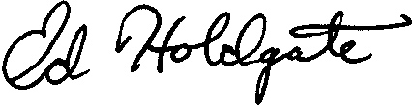
Ed Holdgate
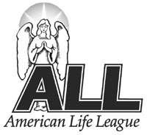 An Associate of American Life League, Inc.
NHRTL President

