New Hampshire Right to Life


Post Office Box 421 Merrimack NH 03054
603.626.7950 life@nhrtl.org www.nhrtl.org

July 5, 2004

Dear Pastor:

We are pleased to invite you and your congregation to the Second Annual pro-life picnic! Join us on Saturday, July 24, from Noon to 5pm at Pawtuckaway State Park for a great time of fellowship and fun with NH pro-lifers.

This picnic features family fun with games like batmitton, frisbee, croquet, and water balloon tosses. Get face-painted and use the park slides, swings, and life-guarded beach if you like. Pictures of last year’s event with nearly 90 pro-lifers are on-line at www.nhrtl.org/picnic/2004

The picnic (on tables in the huge pavilion) features all-you-can-eat-until-they’re gone hots & hamburgers, chips, veggies, salads, and soft drinks. Tickets are just $5 each for ages 12 and up, and kids 11 and under are free. Additionally, there is the normal
State Park admission fee of $3 per person over age 11 in cash at the park entrance gate.

Pawtuckaway State Park is about 15 miles Northeast of Manchester – about 4 miles
North of Raymond in Nottingham, NH. Exact directions are on-line at www.nhrtl.org/picnic/2004 and most people can use Exit 5 off Route 101 in Raymond.
We post signs along the route to make it easy.

We request your RSVPs by leaving a message at 626-7950 or by sending an e-mail to life@nhrtl.org Please provide your full name, telephone number, and mailing address with your RSVP before July 18. Enclosed is a flyer advertising this pro-life picnic. Please help us circulate this invitation by posting it on your church bulletin board.

Many thanks and His Peace to you,
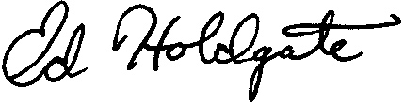
Ed Holdgate
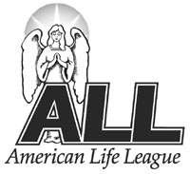 An Associate of American Life League, Inc.
NHRTL President

