PLEASE CONTACT THE MEMBERS OF THE HOUSE EDUCATION
COMMITTEE ASK THEM TO SUPPORT AMENDMENT TO HB-39

On November 16, 2005, the House Education Committee will consider an Amendment to House Bill 39 that will give PARENTS the right to opt their children out of any Family Life and Sexuality Health Course which conflicts with their personal religious beliefs.

HB-39 will provide PARENTS with a tool to avoid a length and cumbersome process now required to opt children out of Sex Education courses that may conflict with religious beliefs taught in the homes.

HB-39 will provide PARENTS with basic local control by giving PARENTS full discretion as to whether or not any Sex Education materials or class discussions would be counter to religious and family values taught in the homes.

HB-39 will give PARENTS a simple Form that they can fill out and submit to local school officials advising them of a conflict with religious values. It will allow PARENTS to have the final say about whether or not their child will receive instructions in a subject matter that many consider essentially tied to their religious principles.

PLEASE CONTACT ALL MEMBERS OF THE EDUCATION COMMITTEE IMMEDIATELY AND TELL THEM TO SUPPORT THIS AMENDMENT TO HB-39.
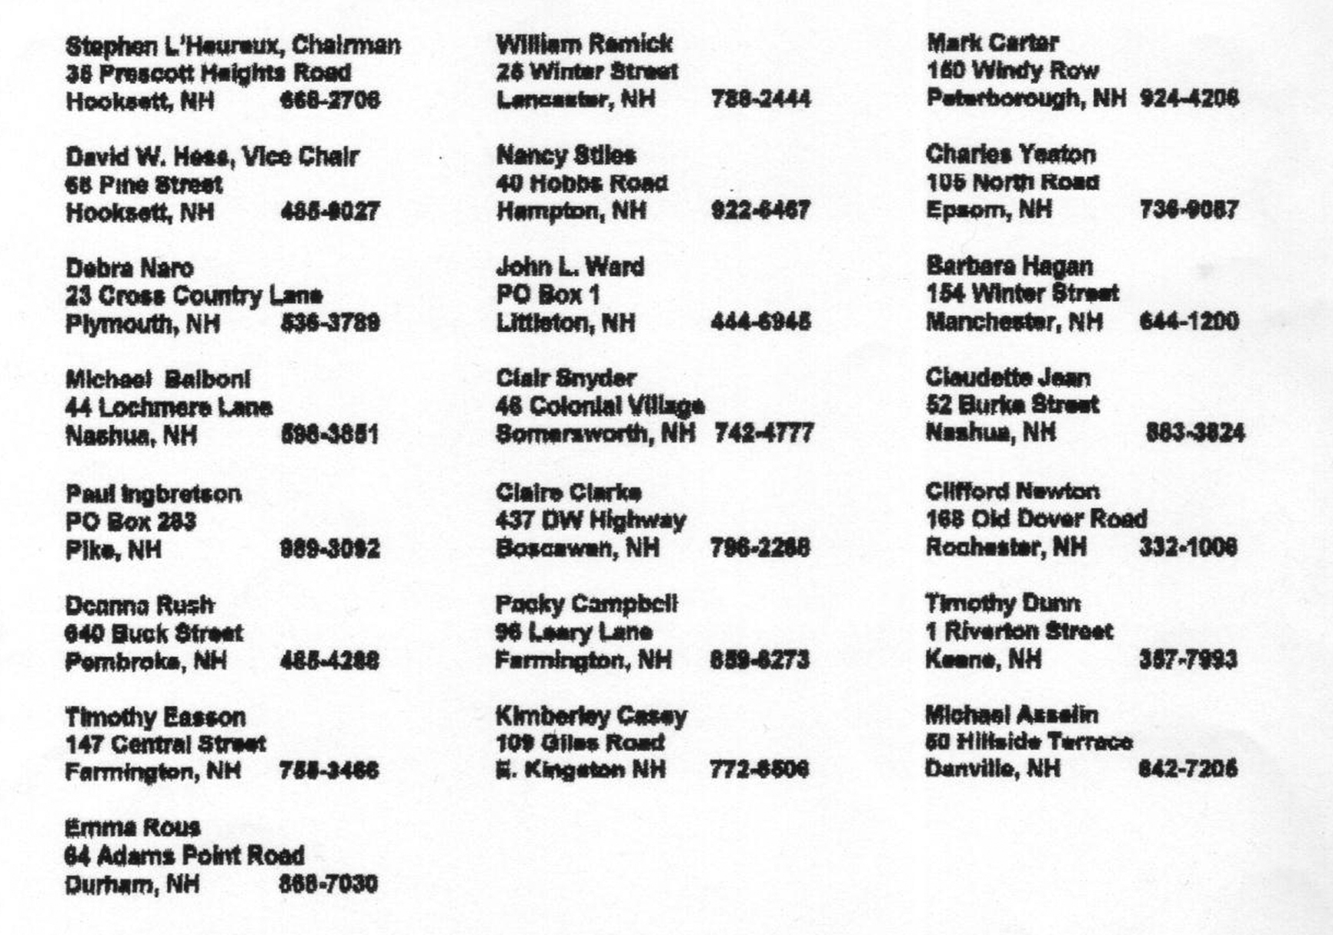
It is imperative that you call each and every member of this Committee
to encourage them to give PARENTS the Local Control they deserve.
Please feel free to copy and distribute this alert widely. Thank you.

