Grace Ministries International
263 Rte 125 Brentwood NH 03833

Presents

“Operation Outcry; Silent No More”
NH Pro-Life Conference
Saturday, November 12, 2005, 11am- 2pm
Come join us in a time of prayer, education
on the effects of abortion on women, and
what we can do to help in this effort.

Suggested donation is $15/pp advance
$25/pp at the door
Complimentary lunch is included

Please RSVP by October 12, 2005
prolifeambassador@msn.com
Or by calling Grace Ministries International
at 603-642-7848 or visit www.gracemi.org

The first NH episode of “Faces of Abortion” will be shown.
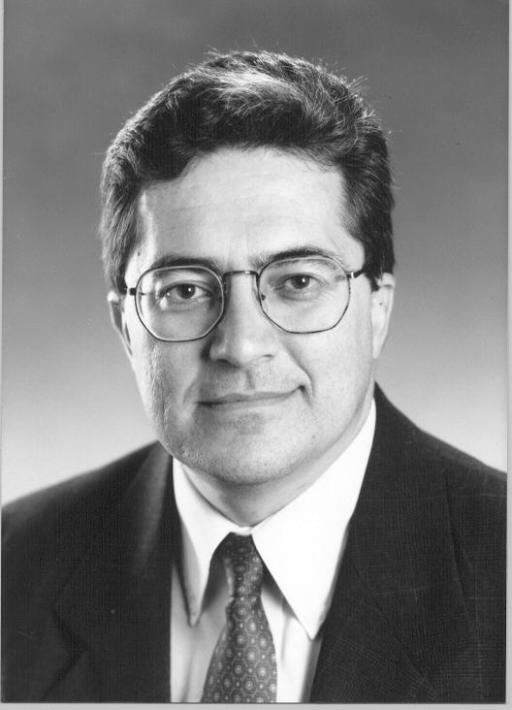
Allan Parker
President, The Justice Foundation

Keynote Speaker

Allan Parker, President of The Justice Foundation, is a former Professor of Law at St. Mary’s University in San Antonio, Texas, where he taught Education Law and Civil Procedure. He was a Visiting Professor at the University of Texas, and studied International Human Rights at the International Human Rights Institute in Strasbourg, France. He taught International Human Rights at St. Mary’s Institute on World Legal Problems in Innsbruck, Austria in 1992.  The Justice Foundation is currently representing both Norma McCorvey, formerly “Roe” of Roe v. Wade, and Sandra Cano, the “Doe” of Doe v. Bolton, in the effort to overturn the two landmark cases that brought legalized abortion on demand to America. “Both women are deeply concerned and have come to the conviction that abortion is not the answer for women who are in a vulnerable pregnancy,” says Allan Parker, President of the Justice Foundation. | Mr. Parker received his J.D. degree with high honors from the University of Texas School of Law in 1979. He was an Associate Editor of the Texas Law Review, a Chancellor, Order of the Coif, and Order of Barristers for his outstanding advocacy skills. He graduated Phi Beta Kappa from the University of Oklahoma with a B.A. in Economics.  The Justice Foundation provides free legal representation in landmark cases to protect women's health, property rights, limited government, free markets and parental rights. TJF, through litigation and education, seeks to protect the fundamental freedoms and rights essential to the preservation of American society. To reinvigorate public education, strengthen the family, and promote the private sector business climate, government must be limited to its traditional and appropriate role.

 | Operation Outcry  Kelly Roy  NH State Leader  Cell 603-918-7828  prolifeambassador@msn.com

Operation Outcry New Hampshire

