
Please Join Us
A special brunch featuring guest speaker:
Allan Parker
President of The Justice Foundation,
Founder of Operation Outcry

OPERATION OUTCRY is the project of THE JUSTICE FOUNDATION to end legal abortion by exposing the truth about its devastating impact on women and families. We believe that this will be accomplished through prayer and with the testimonies of mothers who have taken the life of their own unborn babies and of others who have suffered harm from abortion. We are working to restore justice and to protect women, men, and children from the destruction that abortion causes.
Visit us and enjoy this dynamic speaker to catch the vision for Operation Outcry.
www.operationoutcry.org

Brunch Menu

Chilled Melon Soup and/or Strawberry Soup
Prosciutto and Goat Cheese Strata
Sausages
Fresh Fruit
Black Pepper Biscuits with Smoked Salmon and Dill
Assorted Pastries (Maple Walnut Scones, Lemon Poppy Scones and Sticky Buns)
Juice/ Coffee/ Tea

October 27, 2007 10:30am
Cost $15/pp

Grace Ministries International
265 Rte 125, Brentwood, NH 03833

Register with Kelly Roy, Operation Outcry NH State Leader/ NE Coordinator via
prolifeambassador@msn.com

**Please see Allan Parker’s biography below.

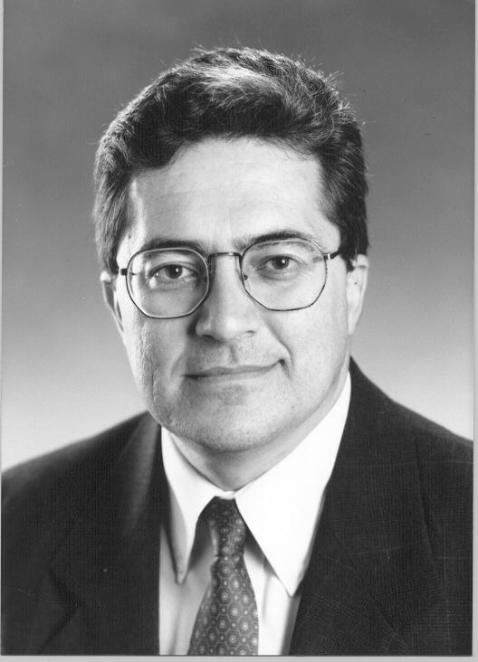

Allan E. Parker, Jr., President
The Justice Foundation

Expertise

Women's Health
Limited Government
Parental Rights
Education Reform
Economic Freedom
Property Rights

Newsmaker

Wall Street Journal
Jim Lehrer News Hour
Hannity and Colmes
Houston Chronicle
Dallas Morning News
Washington Times
Los Angeles Times
O’Reilly Factor
BBC Radio

The Justice Foundation
8122 Datapoint, Ste. 812
San Antonio, TX 78257
210-614-7157
www.thejusticefoundation.org

Allan Parker, President of The Justice Foundation (formerly the Texas Justice Foundation), is a former Professor of Law at St. Mary’s University in San Antonio, Texas, where he taught Education Law and Civil Procedure. He was a Visiting Professor at the University of Texas, and studied International Human Rights at the International Human Rights Institute in Strasbourg, France. He taught International Human Rights at the St. Mary’s Institute on World Legal Problems in Innsbruck, Austria in 1992.
The Justice Foundation is the lead counsel for Norma McCorvey, formerly “Roe” of Roe v. Wade, and Sandra Cano, the “Doe” of Doe v. Bolton, in their effort to overturn the two landmark cases that brought legalized abortion on demand to America. “Both women are deeply concerned and have come to the conviction that abortion is not the answer for women who are in a vulnerable pregnancy,” said Allan Parker, President of the Justice Foundation.
Mr. Parker is the author of numerous works on school choice and a frequent lecturer on education topics. He and the Justice Foundation were selected in 1996 by the Texas State Board of Education to evaluate the Texas Open-Enrollment Charter Program.
Prior to teaching, Mr. Parker was in the general civil practice of law as a trial lawyer. He was Board Certified in Civil Trial (1987-1992) and Personal Injury Trial Law (1988-1993) by the Texas Board of Legal Specialization.
Mr. Parker received his J.D. degree with high honors from the University Of Texas School Of Law in 1979. He was an Associate Editor of the Texas Law Review, a Chancellor, Order of the Coif, and Order of Barristers for his outstanding advocacy skills. He graduated Phi Beta Kappa from the University of Oklahoma with a B.A. in Economics in 1974.
The Justice Foundation provides free legal representation in landmark cases to protect women's health, property rights, limited government, free markets and parental rights. TJF, through litigation and education, seeks to protect the fundamental freedoms and rights essential to the preservation of American society. To reinvigorate public education, strengthen the family, and promote the private sector business climate, government must be limited to its traditional and appropriate role.

