The Chester Rod and Gun Club
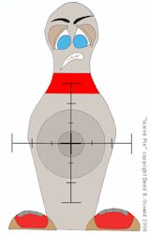
http://www.chesterrodandgunclub.com/

Presents:
2011 Pin Shoots

The out door shoots this year will be run with in the morning 8:30 sign up, shooting starting at 9:00 and should end around 12 noon.

April 16th
May 14th
June 25th
July 30th
August 20th
September 17th
October 29th

For more information contact:
Joe Diamond 603-895-3224
chester_pinshoots@comcast.net

Directions: From the south take Route 93 north to exit 4 (Route 102 East) go right follow through rotary to Chester (when you come to the intersection of Route 102 and 121 in Chester you are about 4.5 miles from the Club continue on Route 102) look for Club sign on right. From Raymond follow route 102 until you see the river, about 1 mile past that you will see the club sign on your left. That road is Rod and Gun Club road. We are at the end of it!

